LMS Creation
Institution
Course
Name

Audience: Higher Ed. students.
Introduction: Beginning of Acrylic Painting
Acrylic painting uses the acrylic paint. Acrylic paint refers to a fast-drying paint that is composed of a pigment suspended in acrylic polymer emulsion and plasticizers, metal soaps, stabilizers, deformers or silicon oils. For this class, students will draw onto canvas paper with pencil, and mix a palette of simple colors. Students are argued to show commitment by working together to facilitate understanding of the lesson concepts. The students will learn the lesson basics by handling acrylic paints, brushes and exploring various techniques in painting. This will facilitate the student to achieve the following objectives.
Objectives of the Course
- Introduce the learners to the cordial processes of visual insights and artistic expressions.
- Help the students to build on the ability to verbalize ideas and processes in art making.
- Develop and improve the confidence of the learners in using painting as their primary approach as a form of art.
- Teach and develop a better understanding of history, styles, and the modern issues affecting painting as a form of art.
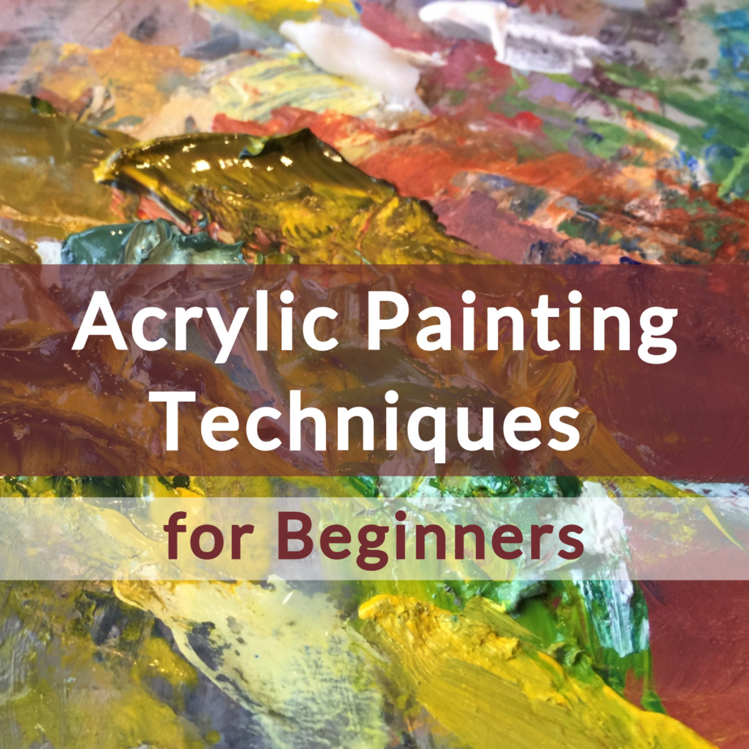

Lesson Page

a. Materials & Procedure
- Acrylic paint (white, black, blue, yellow and red)
- Paint brushes.
- Water
- Canvas
- Paper plates
b.Developing Student’s Ability to Verbalize Ideas & Processes in Art Making
Creative expression in the arts is important. The learners will be taken through some art works that were developed in the past. They will also be taken through a step by step process to show how the artists verbalized their ideas and processes in art making.
c. Improving the Learners Confidence
This will be achieved by ensuring that the learners have access the past art works and are taken through practice to sharpen their painting skills.
d.History, Styles/Techniques and Modern Issues Surrounding Painting
Painting has proved over time to be one of the most marketable forms of art. Acrylic painting is a relatively recent innovation and has also proved to be a worthy form of art (Swimm, 2005). The use of the various acrylic painting techniques have resulted in some of the most well-known as well as desirable works of art around the globe.
We shall start learning by going through an overview of the famous artists. In addition, we could also start by looking at great master works of art. This will serve as a model to aspire to or a genre to provide guidance that will help the learners successfully understand art. This will include portraits, or landscapes as well as some other natural settings such as mountains. They will later on work on a similar example as the lessons progresses.
The current challenge facing painting is the conflict that has erupted between the new world audience of the visually fluent individuals against the traditional art-world elites (Current issues in 19th-century art, 2007).
e. Techniques/styles
There are various techniques used in acrylic painting. However, in this lesson we shall only go through three techniques which are as discussed below:
- Dry Brush
This is simple to execute. It uses a brush that has been dipped in water after which an artist created a scratchy, textured uneven movement of lines on his or her canvas. The brush should be as dry as possible and loaded with paint (Swimm, 2005).
- Washing
Dilute a paint by adding enough amount of water in order to create a translucent wash.
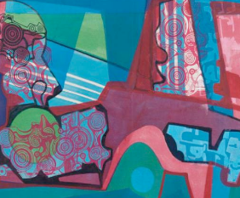
- Stippling
Uses a collection of tiny dots. In the recent, artists have been constructing varying degrees of shading that is based on boldness or closeness of the assemblage of the dots create real dimension.
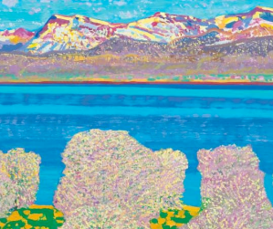
Authentic Learning Activity
While we would have already learned much about painting in the previous lessons, we will now get a chance to show our creativity. All students will be required to walk out of class carrying all materials that will be required for drawing. Each of the students will draw whatever will be on their sight. In simple terms, students can draw the buildings, the appearance of mountains and forests as they appear in the horizons or the playing ground. The authentic learning activity is designed to assist the student connect what they have learned with the real world.
Links:
The links below provide more information on the topic.
https://www.udemy.com/courses/search/?q=acrylic+painting&ranMID=39197&ranEAID=r*YuGS5RXlI&ranSiteID=r.YuGS5RXlI-ei94tIQQhrTiDQhQwaFOXg&LSNPUBID=r*YuGS5RXlI&utm_source=aff-campaign&utm_medium=udemyads
https://www.linkedin.com/learning/search?keywords=acrylic%20painting&src=aff-lilpar&veh=aff_src.aff-lilpar_c.partners_pkw.1273183_plc.OLAPHASE%20SDN.%20BHD._pcrid.449670_learning&trk=aff_src.aff-lilpar_c.partners_pkw.1273183_plc.OLAPHASE%20SDN.%20BHD._pcrid.449670_learning&clickid=X89whvyh1xyLT-ewUx0Mo3EtUkETpM15JW1sQ00&irgwc=1
Discussion Forum
Students should consider how the acrylic painting techniques have changed over the years. It will expound their knowledge relating to history, styles, and the modern issues. The students are required to do an internet search on acrylic painting techniques. The discussion will be designed to complement and arouse their personal interest. This will assist to explore technology-rich resources and activities that promote meaningful, standards-based learning.
A discussion on challenges facing acrylic painting will facilitate achievement of the course objectives. Thus, the students will be divided into groups where they will share practical ideas. It will bridge the gap between what the students learn and its application in real life scenario. It will also ensure that the task are applicable and interest the learners.
Assessment Question
- What is the importance of studying Acrylics?
- What is used to make acrylics?
- Oil
- Polymer emulsions
- Eggs yolks
- Water
- When was acrylics used for the first time?
- 1940’s
- 1990’s
- 1850’s
- 1900’s
- What is the average drying period for acrylic paints?
- Overnight
- Two hours
- 15-45 min
- 5-20 min
- How is acrylics prevented from lifting
- Which kind of vanish should I use to finish acrylic on canvas?
- How to create cracked backgrounds?
- How to dilute acrylic paint that is too thick?
- How to paint clean, crisp lines with acrylics?
- For how long should a person take before rinsing acrylic paint off the brush?
- What part of the brush should a painter immerse in paint?
- What is gesso?
- How is gesso prepared?
- How should a painter prepare a desk before starting to use acrylic paint?
- Where should I mix the paint?
- On what can I paint?

Reference
Current issues in 19th-century art. (2007). Zwolle: Waanders.
Swimm, T. (2005). Acrylic painting: Step by step. Irvine, CA: Walter Foster.

